JAVA LAB PROGRAM 7

import java.util.*;

interface Polygon {

double getPerimeter();

double getArea();

}

class Triangle implements Polygon {

double a, b, c;

public Triangle(double a, double b, double c) {

this.a = a;

this.b = b;

this.c = c;

}

public double getPerimeter() {

return a + b + c;

}

public double getArea() {

double s = (a + b + c) / 2;

return Math.sqrt(s * (s - a) * (s - b) * (s - c));

}

}

class Square implements Polygon {

double side;

public Square(double side) {

this.side = side;

}

public double getPerimeter() {

return 4 * side;

}

public double getArea() {

return side * side;

}

}

public class Polygons {

public static void main(String[] args) {

Scanner input = new Scanner(System.in);

int ch = 0;

while (ch != 3) {

System.out.println("1. Triangle\n2. Square\n3. Exit\nEnter your choice:");

ch = input.nextInt();

switch (ch) {

case 1:

System.out.println("Enter side a:");

double a = input.nextDouble();

System.out.println("Enter side b:");

double b = input.nextDouble();

System.out.println("Enter side c:");

double c = input.nextDouble();

Polygon p = new Triangle(a, b, c);

System.out.println("Perimeter: " + p.getPerimeter());

System.out.println("Area: " + p.getArea());

break;

case 2:

System.out.println("Enter side:");

double side = input.nextDouble();

Polygon p2 = new Square(side);

System.out.println("Perimeter: " + p2.getPerimeter());

System.out.println("Area: " + p2.getArea());

break;

case 3:

System.out.println("Thankyou");

break;

default:

System.out.println("Invalid choice.");

}

}

}

}

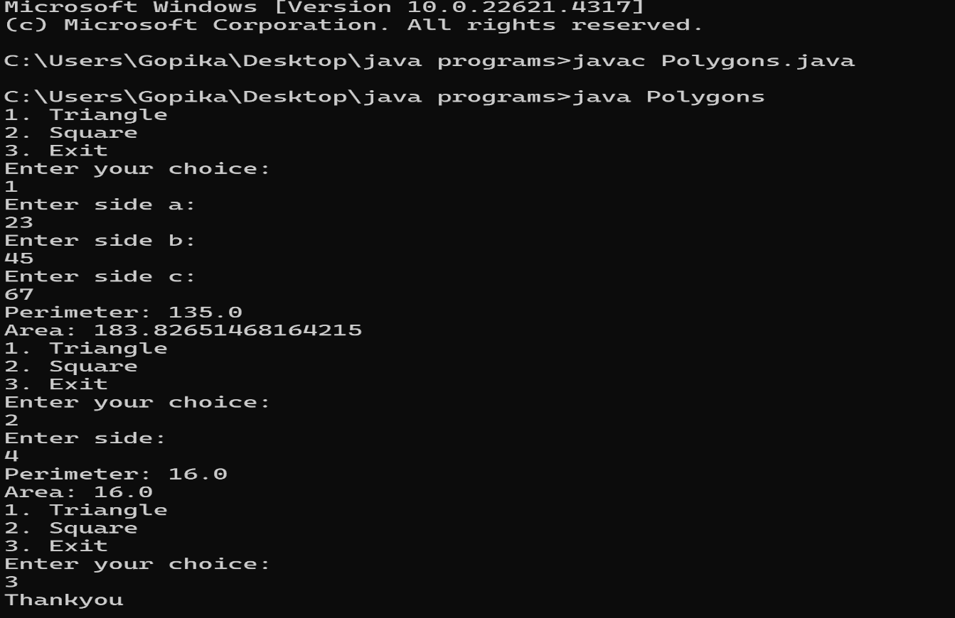OUTPUT